**Install and Setting up Maven build tool**

**Step 1**: Go to Maven's download page at https://maven.apache.org/download.cgi

**Step 2**: Click on the **apache-maven-3.8.1-bin.zip** download link and start the download.

**Step 3**: Once the download is finished, go to the downloaded directory and extract the .zip file into a convenient directory of your choice.

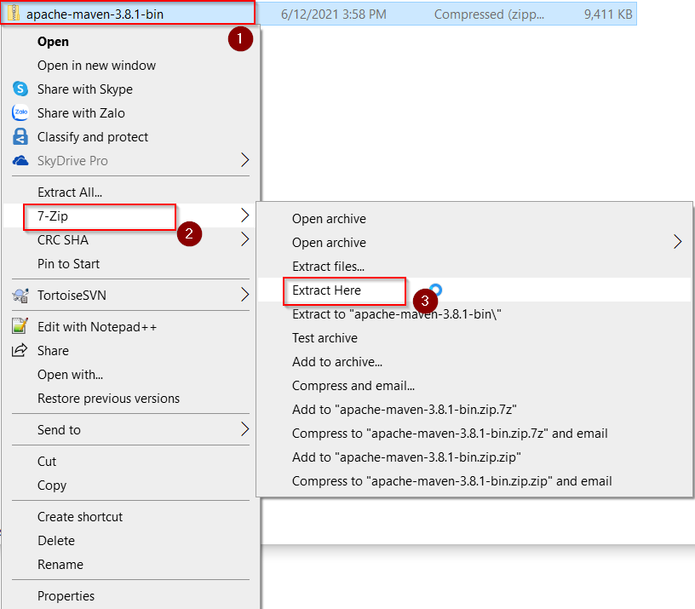

We get the folder: **apache-maven-3.8.1**

**Step 4**: Create the folder **C:\apache**

**Step 5**: Copy the folder “**apache-maven-3.8.1”** to the folder **C:\apache**

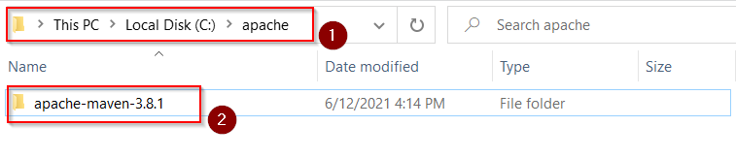

**Step 6**: Now we need to create one more environment variable called MAVEN_HOME in a way that is similar to the way in which we created JAVA_HOME. Enter the extracted Maven zip directory's path as the value for the MAVEN_HOME environment variable.

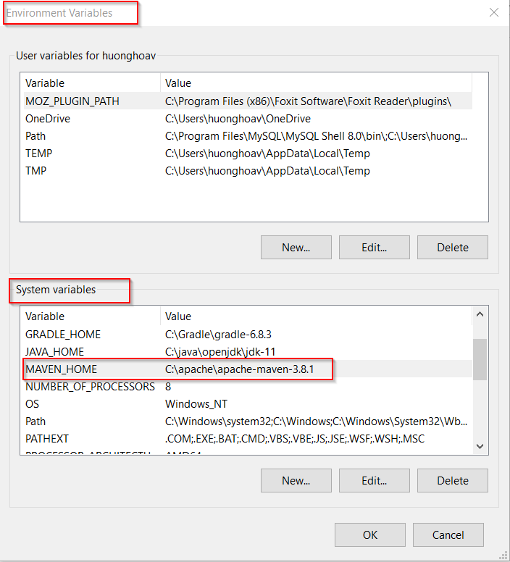

**Step 7**: Finally, append the MAVEN_HOME variable to the PATH environment variable as well. Double-click on the path variable and click on the **New** button to enter **%MAVEN_HOME%\bin** as the value.

Now click on the **OK** button.

**Step 8**: Verify the maven installation

Open a new CMD window and type: **mvn –version**

